Title options

- Defaunation-driven small mammal booms may favor snake predators
- Defaunation boosts small mammals—and the snakes that eat them
- Loss of large wildlife benefits small mammals and the snakes that eat them

Authors

Owen McCool¹, Jacob Vogin¹, Juan Pablo Castro Arevalo², and Therese Lamperty*^{1,3}

- Department of Wildlife Ecology and Conservation, University of Florida, Gainesville, FL 32611, USA
- College of Biological and Environmental Sciences, Universidad San Francisco de Quito, Quito, Ecuador
- Estación de Biodiversidad Tiputini, Colegio de Ciencias Biológicas y Ambientales, Universidad San Francisco de Quito, Quito, Ecuador

*Corresponding author: jlamperty@gmail.com

Keywords: biodiversity loss, density compensation, herpetofauna, trophic cascade, tropical forest conservation

ABSTRACT

Defaunation is becoming increasingly widespread across the tropics due to unsustainable hunting. Increases in small mammal abundances are a well-documented symptom of defaunation. Because small mammals are key prey for many snake species, these shifts in the prey base may extend to higher trophic levels via bottom-up effects. However, the effects of defaunation on snakes remain largely unexplored. To address this, we used a combination of standardized visual encounter surveys targeting small mammals and snakes, supplemented by opportunistic and third-party observations at two comparable field sites in the Ecuadorian Amazon with differing levels of exposure to hunting. Additionally, to help us understand if potential bottom-up effects are driven primarily by shifts in small mammals or if they reflect broader restructuring across multiple prey base components, we recorded detections of other potential prey taxa (frogs and lizards). Results indicate a potential trophic cascade, with small mammal detections ~3.5x higher in the defaunated site and marginally higher detection rates of mammal-eating snakes. This could indicate a bottom-up restructuring of snake community structure. In general, most of the families of frogs and lizards we that we documented either increased in the hunted forest or showed no change; however, frogs in Craugastoridae were slightly less abundant in the hunted forest. This aligns with previous work indicating this family is negatively impacted by the loss of litter turnover when peccaries and other large terrestrial animals are locally extirpated. Taken together, our results provide some insight into how defaunation -- a widespread phenomenon -- may affect snake communities and abundances. Because snakes play impactful ecological roles as both predators and prey, we present this study as motivation for further work to understand trophic cascades associated with defaunation and how they impact snakes and other herpetofauna.

INTRODUCTION

Defaunation across tropical forests has emerged as a major anthropogenic threat to biodiversity (Dirzo et al. 2014; Benítez-López et al. 2019; Osuri et al. 2020; Bogoni et al. 2020). Indirect effects that stem from the depletion and reorganization of the faunal community such as trophic cascades and disruptions in species interactions, create some of the farthest-reaching consequences (Galetti & Dirzo 2013; Young et al. 2016; Burkepile & Thurber 2019; Pires & Galetti 2023). Because defaunation can lead to trophic downgrading and biomass collapse – transforming faunal communities into systems dominated by smaller-bodied species (Galetti et al. 2017; Bogoni et al. 2018; Benítez-López et al. 2019) –it causes ecological cascades that fundamentally change or destroy critical ecosystem services (Poulsen et al. 2013; Bogoni et al. 2020b; Portela & Dirzo 2020). Some of the most well-documented effects of defaunation include changes in animal-mediated seed dispersal roles that affect forest regeneration and carbon storage (Brodie et al. 2009, 2025; Bello et al. 2015; Lamperty et al. 2025), reduced herbivory and physical understory damage influencing biogeochemical processes (Rosin et al. 2017; Berzaghi et al. 2018; Lamperty et al. 2020; Tuo et al. 2024) and increased seed predation driven by greater abundances of rodents, which often benefit from reduced predation and competition in defaunated forests (Kurten 2013; Galetti et al. 2015a, 2015b; Rosin & Poulsen 2016).

In addition to impacting seed dispersal and survival, this increase in rodents – which are key prey and generalist predators in tropical forests – could have other far-reaching effects through trophic cascades in defaunated forests, specifically on mammal-consuming snakes. For example, in the African savanna when large mammals were excluded from the environment, higher abundances of rodents resulted in significantly higher numbers of small mammal-eating snakes (McCauley et al. 2006). Snakes as well as other herpetofauna are a severely understudied group that are suffering from poorly-understood global declines (Böhm et al. 2013; Roll et al. 2017; Miranda & P 2017a; Zipkin et al. 2020). The increases in rodent abundances found in defaunated forests are significant (e.g. a seminal study in the Amazon documented up to a 45% increase) (Galetti et al. 2015b), and this could translate into greater abundances of mammal-consuming snakes, such as Boidae, which consume small mammals as a primary component of their diet (Arteaga et al. 2024). Despite this association, and the fact that this same phenomenon has been linked to increases in snake abundances in the African savannah (McCauley et al. 2006b), how defaunation may indirectly reshape snake communities has yet to be investigated in tropical forests to the best of our knowledge. However, evaluating these effects is critical given the important ecological roles snakes play across multiple trophic levels as both prey and predators to a wide range of taxa (Zipkin et al. 2020; Pinto‐Coelho et al. 2021).

The Amazon basin hosts some of the most species-rich reptile communities in the world (Rabosky et al. 2019). Snakes serve vital roles as both predators and prey in forest food webs, helping to regulate populations of small mammals, reptiles, amphibians, birds, and more while simultaneously serving as prey for larger predators. Snakes have been connected to driving changes in prey behaviors (Bouskila 1995) and, in invasive contexts, reshaping entire ecosystems (Wiles et al. 2003; Willson 2017; Rogers et al. 2017). Snakes are also the dominant drivers of nest predation for many tropical bird species (Weatherhead & Blouin-Demers 2004; Robinson et al. 2005; Visco & Sherry 2015b; Fernandez et al. 2019; Londoño et al. 2023). For example, in fragmented rainforests of Costa Rica, snakes are considered important mesopredators and account for up to 80% of antbird nest predation events (Visco & Sherry 2015a). Given the critical conservation concern around plummeting numbers of tropical birds (Blake & Loiselle 2015), understanding if and how one of their top predators is being impacted by a major global change driver such as defaunation is a critical part of understanding how tropical forest faunal communities are changing and what conservation actions should look like. Wildlife conservation efforts in areas around the world exposed to hunting have traditionally focused on recovering target game species, despite the heavy potential for hunting to also affect many non-target components of the ecosystem (Newing n.d.). In the context of our study, recognizing how the loss of larger fauna may alter prey communities and subsequently influence predators like snakes highlights the importance of considering hunting as an entire system-level disruption event. Incorporating knowledge of these indirect effects into conservation planning may improve our ability to anticipate how tropical forest communities respond to defaunation in the long-term, as well as to identify management strategies that maintain overall ecological function alongside promoting the recovery of hunted species. Understanding what these indirect effects are help conservationists move beyond protecting individual hunted species and toward supporting and maintaining species interactions that support healthy tropical forests. Future projections and understanding the directions these systems are headed, which is important for understanding how to help them

The Amazon is home to many larger-bodied snake species, which occupy a wide range of trophic positions and consume a diverse prey base. Because of this, snakes act as critical connectors among feeding guilds and contribute heavily to the structure of Amazonian food webs (Pinto‐Coelho et al. 2021). The diet of numerous tropical snake species includes amphibians and other reptiles, which may respond in their own ways to defaunated conditions via changes in predation, habitat structure, or resource availability – adding further complexity to how defaunation may impact the terrestrial food web. By driving increases in small mammals, defaunation’s bottom-up effects on snake communities may be restricted to mammal-consuming guilds. However, rodents may also influence the foodweb as predators themselves. Many rodent species are omnivorous and their numbers have been correlated with declines in lizard abundances in New Zealand (Monks et al. 2024). This may mean that defaunation could be connected to changes in multiple snake prey groups, potentially causing a broader compositional change in snake communities of tropical forests. Looking at the patterns caused by defaunation under a wider context among different taxa may provide a more complete understanding of how defaunation indirectly influences higher trophic levels.

This study represents the first – to our knowledge – attempt to investigate whether defaunation resulting from unsustainable hunting has indirect effects on snake communities. Studies such as this can provide valuable insight into the cascading effects of defaunation throughout faunal communities and help future conservation efforts in some of the world’s most important ecosystems. In Ecuador’s Yasuní Biosphere Reserve, a global biodiversity hotspot of critical conservation concern (Bass et al. 2010a), we compared snake communities and simultaneously assessed abundances of key prey groups (rodents, frogs, and lizards) at two ecologically comparable sites: one of which was faunally-intact and one which is defaunated due to decades of unsustainable hunting exposure (Holbrook & Loiselle 2009). We compared snake diversity, dietary guild composition, and density. We also estimated relative small mammal abundances as an index for snake prey availability and recorded detections of other potential prey taxa (lizards and frogs) to assess whether defaunation-driven changes in prey availability were restricted only to small mammals or reflected broader changes across the snake prey base. We predicted that rodents and mammal-eating snakes would be more abundant at the defaunated site. Additionally, we predicted that some frog and lizard families may respond differently to defaunation; potential effects include increased predation by small omnivorous mammals as well as by snakes with mixed diets that may benefit from higher rodent availability, but also consume frogs and lizards. Additional effects of defaunation and the associated loss of large terrestrial vertebrates that are outside the scope of the present study may also impact frog and lizard communities in poorly understood ways, making predictions challenging. We also hypothesized that broader compositional changes may emerge in the snake communities following the complicated potential food web changes caused by defaunation.

METHODS

Study Site

Our research took place between May and August in 2024 and 2025 in the Yasuní Biosphere Reserve in the western Amazon Basin located in Ecuador (Figure 1). The Reserve is a large and extremely biodiverse swath of Amazonian forest covering 16,820 km² (Bass et al. 2010; Garwood et al. 2023). The region is characterized as ever-wet, with no significant dry season, high humidity (>80% on average), approximately 3000-3600 mm of rainfall annually, and an average annual temperature of 24-27 °C (Garwood et al. 2023). Relatively higher precipitation and cooler temperatures typically occur between March to July, with May being the wettest month (Bass et al. 2010).

Estación Científica Yasuní (Yasuní Research Station, henceforth YRS) served as our base for the hunted forest area. Hunting pressure on the local fauna has been steadily increasing in the area since the creation of Maxus Road Oil Road in the early 1990s and the establishment of multiple permanent Woarani settlements along it (Espinosa et al. 2014). Hunting-induced defaunation has now been well documented in the area, with several comparative studies leveraging the more remote forest surrounding the Tiputini Biodiversity Station (TBS) as a faunally-intact contrast (Holbrook & Loiselle 2009; Blake et al. 2013; Ghanem & Voigt 2014; Espinosa et al. 2014). Throughout this study, hunters were regularly encountered in the forests surrounding YRS.

Our faunally-intact site was based around the Tiputini Biodiversity Station (TBS), which is ~28km east of YRS (Figure 1). TBS is remote, only accessible via boat, and highly protected from hunting (Holbrook & Loiselle 2009). Forests surrounding YRS and TBS have been leveraged in several comparative studies that contrast the two as environmentally and structurally comparable defaunated and faunally-intact areas(Holbrook & Loiselle 2009; Blake et al. 2013; Ghanem & Voigt 2014; Espinosa et al. 2014). Both areas are composed of mature unlogged forests of terra firme and varzea habitats); as such, we expect they are capable of supporting the same general pools of herpetofaunal species.
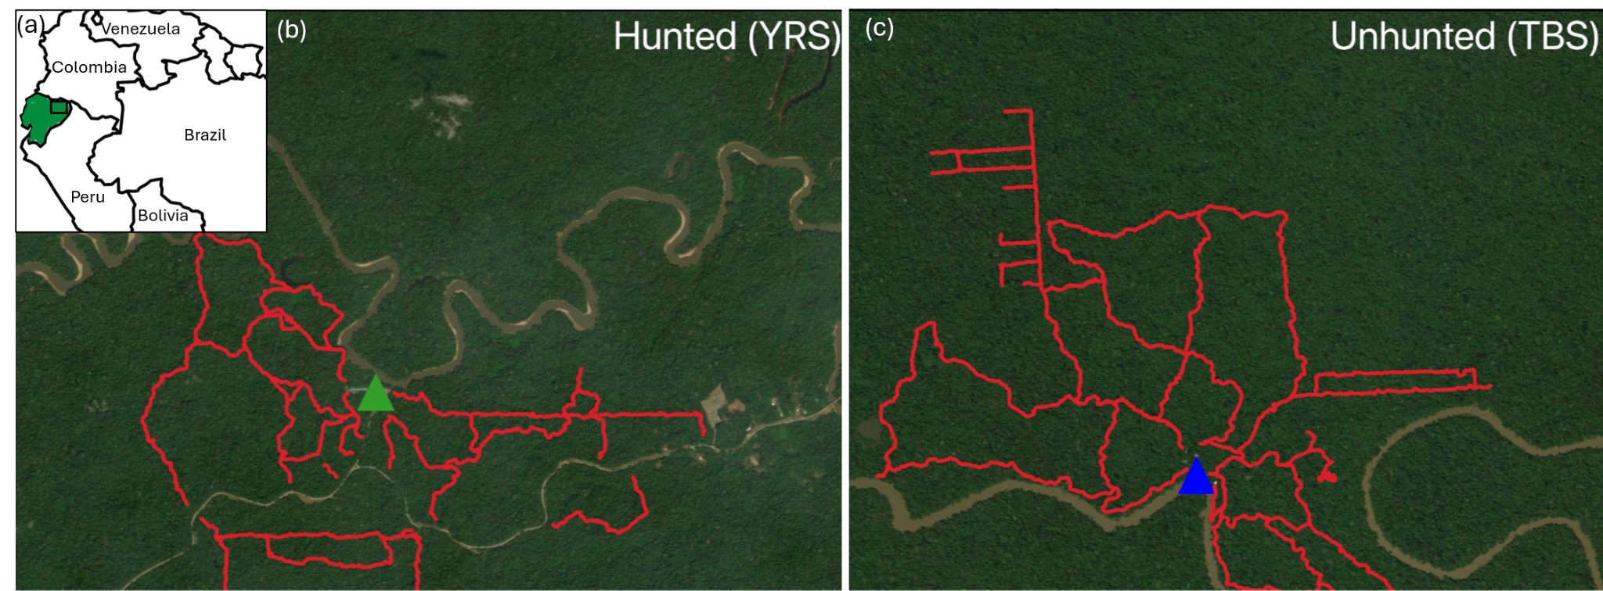
Figure 1. a) Ecuador (green) with study region denoted by the black rectangle and b) transect routes in the hunted and c) unhunted forests. position in South America and the locations of each of the two research stations within Ecuador.

Study Design

- Survey protocol
To sample for herpetofauna and small mammals, we employed Nocturnal Visual Encounter Surveys (NVES). Trail systems between the two forest types (hunted and unhunted) were divided up into segments of comparable lengths (48 in unhunted and 47 in hunted forest). These segments were then measured and treated as individual surveys. Although these segments follow existing trail systems, distance sampling could still be employed on the non-linear transects so long as they were measured correctly (Chua et al. 2026). Due to the presence of the oil road cutting through the hunted forest area, we also had to account for road-edge effects. All surveys with trailheads originating at the road began at least 50 meters from the road to reduce edge effects, as herpetofaunal abundance and diversity have been shown to increase with distance from forest edges (Maynard et al. 2016). While 100 meters is considered a more effective threshold for minimizing edge influence in the Ecuadorian Amazon, logistical constraints necessitated a compromise at 50 meters.

Survey effort was kept comparable in both the hunted and unhunted forest types (Table 1). During surveys, teams of (typically) 2–3 project members conducted walks at a pace of approximately 1.4 to 1.6 kilometers per hour, carefully looking for small mammals, snakes, and other herpetofauna in the canopy, understory, and on the ground. Survey routes consisted of differing combinations of the aforementioned segments. Search effort also included closely examining all accessible forest streams or ephemeral pools that intersected or bordered the trail. Surveys generally began between 20:00 and 21:00 and concluded between 22:30 and 00:15. Gaia GPS was used to time surveys and to record survey tracks and segment distances. Each time a snake, frog, or lizard was found, the timer was paused to record data (it was not necessary to pause timers to tally small mammals as we were only tallying them). We recorded the number of small mammals (rodents, opossums, etc.) that were encountered during nocturnal surveys to quantify the abundances of the mammalian prey base at each station.

When a snake, lizard, or frog was detected we identified it to the lowest possible taxonomic level (species-level for all snakes), consulting literature and online resources when we were not confident while in the field (Arteaga et al. 2024). Additionally, we took a GPS point using a Garmin GPSMAPS 64x, noted the temperature and humidity, time of detection, whether the individual was on the ground, in the understory, or in the canopy, and the observer that spotted the animal. We also documented whether the animal was found in terra firme (upland forest) or varzea (seasonally flooded forest) habitat. Each individual was assigned a unique identifying code. Lastly, we recorded the perpendicular distance of each individual at the position of detection from the trail. Additional data were collected for snakes specifically. Each individual was sorted into a dietary guild category denoting whether small mammals comprised part of its diet or not. Additionally, to account for potential resampling of individuals, we photographed each snake and compared the images.

Table 1: Survey effort details across both study years. Means and standard deviations for search time (hours) and distance (meters) for each forest type (unhunted or hunted) and survey type (afternoon or night).

Forest type | Time of day | Mean duration (hrs) | SD | Mean length (m) | SD
Unhunted | Afternoon | 1.62 | 0.52 | 2183.13 | 743.84
Unhunted | Night | 2.92 | 0.51 | 2439.17 | 600.34
Hunted | Afternoon | 1.80 | 0.46 | 2181.14 | 729.14
Hunted | Night | 2.65 | 0.43 | 2510.16 | 688.20

- Opportunistic and third-party snake observations
We recorded incidental snake observations made by our team and reported by third-party groups. When somebody from our group found a snake while not on an official survey, we took a photograph when possible and recorded it as an opportunistic encounter. When other researchers detected snakes as a part of their independent research projects, they reported it to our team as a third-party encounter and included a photograph when possible. All snakes detected from these methods were identified to the lowest possible taxonomic rank, assigned a unique identifying code, and sorted into a dietary guild category. Note that in cases where individuals could not be identified to species level, the dietary guild assignment could not be made with confidence.

- Environmental data collection
To ensure comparable sampling conditions and weather at both sites, we recorded cloud cover and wind conditions prior to starting surveys and documented the timing of the most recent rain event. During surveys, temperature and humidity conditions were recorded at the start and end of surveys, and at every 30-minute increment of search time. Understory vegetation density was also assessed at the start and end of surveys, and at every 15 minutes increment of search time in order to account for changes in detectability. In order to measure this, we counted the number of leaves intercepting a vertical 1.5 meter-long pole, which was randomly placed 1 meter off the right side of the trail (Lamperty et al. 2020).

- Analyses
All analyses were done on R version 4.6.1 (R Core Team 2025). We used generalized linear mixed effects models to test for differences between the hunted and unhunted forests in detection rates (which serves as a proxy for abundance) of snakes, small mammals, frogs, and lizards. Models were constructed using the ‘glmmTMB’ package (Brooks et al. 2022) and residuals, dispersion, and zero-inflation were assessed to validate model fit using the 'DHARMa' package (Hartig & Lohse 2022). Best fit models were selected based on lowest AIC. We structured models to test for effects of hunting on the detection rates of snakes and their prey (small mammals, frogs, lizards) and to account for potential effects from environmental variables that varied between years and forest types (temperature and relative humidity). To account for potential variation between years not related to temperature and humidity, we also included year as a factor in our model comparisons. To test if hunting and environmental variables differentially affect families, we investigated interactions between these variables.

Small mammals are not identified to the family level and are grouped together in our analyses because we could not identify them in the field. Snakes were almost exclusively from 2 families, Colubridae and Boidae, and to avoid using excessively small sample sizes for other families, we only modeled effects of hunting and environmental variables on these two families.

All models included segment ID as a random effect. Understory density did not vary between sites and was thus not investigated as a predictor. Models proceeded from simple to more complex, and as terms were added, if they did now improve model fit (i.e. did not lower model AIC), they were dropped. To allow for models to pass validation steps, small mammals and snakes categorized by dietary guild were modeled with the response variable as a continuous rate (individuals per 500 m), while frogs, lizards and the two most common snake families were modeled as discrete count data (individuals found per survey), in which case the log distance of each survey was also included as an offset term to account for variation in survey distances.

[insert paragraph on density estimates]

RESULTS

Environmental and habitat variables

Understory vegetation density did not vary significantly along survey routes in the hunted and unhunted forests. Mean vertical leaf overlap across both years in the unhunted forest was 2.23 ± 0.12, SD = 2.04 and in the hunted forest mean = 2.17 ± 0.10, SD = 1.89.

Mean temperatures during nighttime surveys in 2024 were comparable between forest types: 83.22⁰ F ± 0.55 SE (SD = 7.06) in the unhunted and 83.83⁰ F ± 0.59 (SD = 7.21) in the hunted forest. In 2025, nighttime survey temperatures were slightly higher on average during surveys in the unhunted forest: mean = 77.11⁰ F ± 0.26 SE (SD = 2.49) relative to the hunted forest: mean = 75.57⁰ F ± 0.25 SE (SD = 2.50).

Day time surveys were only conducted in 2025, during which temperatures were comparable on average between forest types (unhunted forest mean = 80.56⁰ F ± 0.33, SD = 1.91; hunted forest mean = 79.36⁰ F ± 0.51 SE, SD = 2.99).

Mean relative humidity during nighttime surveys were slightly higher in the hunted forest in 2024 (mean = 90.17% ± 0.50, SD = 4.31) relative to the unhunted (mean = 88.87% ± 0.58, SD = 5.27) and in 2025 (hunted forest mean relative humidity = 93.87% ± 0.37, SD = 3.72; unhunted = 91.36% ± 0.44, SD = 4.16).

Small mammals

Small mammal detection rates (individuals found per 500 m) were significantly greater in the hunted forest (X2 = 53.95, df = 1, p < 0.001). Approximately ~ 3.5x more small mammals, primarily rodents, were detected during nighttime surveys in the hunted relative to the unhunted forest (Figure 1a). Cumulatively, we detected 50 small mammals in the unhunted forest and 176 in the hunted forest. Mean detections per 500 m were 1.20 ± 0.08 SE (SD = 0.45) in the hunted forest and 0.37 ± 0.06 SE (SD = 0.33) in the unhunted forest.

Snakes

Cumulatively, we found 51 snakes in the unhunted forest and 50 in the hunted forest. Species richness was 17 in both forest types. Overall snake detection rates (individuals per 500 m) did not vary with hunting. The mean detection rate in the unhunted forest was 0.34 ± 0.07 SE (SD = 0.87) and in the hunted forest it was 0.35 ± 0.08 (SD = 1.09). Our best fit model testing overall detection rates (not accounting for dietary guild or family) only included a term for relative humidity, although it was not a significant predictor (X² = 1.09, df = 1, p = 0.30). See supplementary materials table S1 for model comparison details.

When opportunistic and third-party detections were included, total detections increased to 205 individuals, comprising 27 unique species in the unhunted forest and 29 in the hunted forest. In the unhunted forest, we had 24 opportunistic detections and 30 third-party detections and the hunted forest had 28 opportunistic detections and 22 third-party detections (Table 1). In general, when detection types were pooled (survey, opportunistic, and third-party observations), broad community composition differences between the hunted and unhunted study areas were apparent (Supplementary Figure S1). The highest occurring genera were Imantodes, Chironius, Helicops, and Corallus, with the hunted site having a higher portion of individuals from the genera Corallus and Eunectes (Supplementary Figure S2).

Both the hunted and unhunted forests were dominated by species from the families of Colubridae and Boidae. Recorded snakes were primarily Colubridae, which was detected approximately 6.5x more frequently than individuals belonging to other families. Of our models testing predictors of Colubridae and Boidae detection rates, the top model included a fixed effect for family (Boidae or Colubridae), humidity, and an interaction between family and hunting. Family was significant (X² = 31.25, df = 1, p < 0.001), humidity was marginally insignificant (X² = 3.40, df = 1, p = 0.06), and there hunting interacted significantly with family (X² = 6.60, df = 2, p = 0.03), with Boidae detected more frequently in the hunted forest relative to the unhunted forest. See supplementary table S2 for model comparison details.

When considering variation in detection rate by dietary guild (categorized as species that primarily consume mammals, species that consume no mammals, and species with a mixed diet), our best fit model included the fixed effect of dietary guild (X² = 58.47, df = 2, p <0.001) and the interaction between dietary guild and hunting (X² = 7.18, df = 2, p = 0.03), as well as humidity (X² = 3.54, df = 1, p = 0.06) and the interaction between dietary guild and humidity (X² = 4.81, df = 2, p = 0.09). See supplementary table S3 for model comparison details.
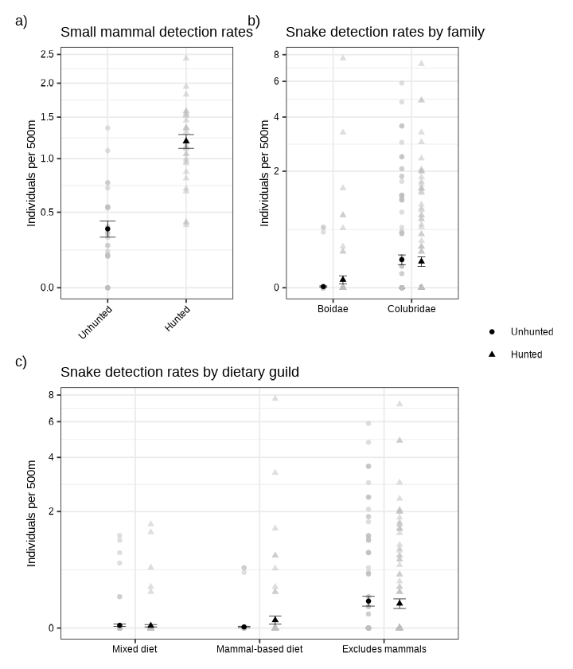
Figure 1. Number of individuals detected during standardized surveys of (a) small mammals, (b) the two most commonly detected snake families, and (c) snakes categorized by dietary guild. Points show mean detection rates across all surveyed segments and bars show standard error. Light gray points in the background show detection rate for each segment surveyed in the study.

Frogs

We found 311 individuals at the unhunted site and 344 at the hunted site consisting of 31 and 35 species, respectively. Mean detection rate in the hunted study area was 3.21 frogs per 500 m ± 0.29 SE (SD = 3.48) and 2.25 frogs per 500 m ± 0.23 SE (SD = 2.67) in the unhunted study area. Our top model based on lowest AIC had the fixed effects of family, hunting, and an interaction between family and hunting and between family and humidity. Model results indicated hunting did not have a significant overall effect on frog detection rates (X² = 1.47, df = 1, p = 0.22), but detection rates varied for different families (X² = 262.99, df = 10, p < 0.001) and there was a significant interaction between hunting and family (X² = 32.72, df = 10, p < 0.001) as well as family and relative humidity (X² = 22.06, df = 11, p = 0.02).

Lizards

Cumulatively, we found 99 lizards in the unhunted study area and 55 in the hunted area belonging to 14 and 11 different species, respectively. Mean detections (lizards per 500 m) were higher in the unhunted forest (0.67 ± 0.11 SE, SD = 1.26) relative to the hunted forest (mean = 0.48 ± 0.09, SD = 1.10). The best fit model included the fixed effects of family, humidity, temperature, and the interaction between family and hunting status. Detection rates varied significantly between families (X² = 146.21, df = 7, p < 0.001) and hunting impacted families differently (family x hunting interaction: X² = 16.28, df = 8, p = 0.04). Temperature did not significantly affect lizard detection rates (X² = 2.40, df = 1, p = 0.12) nor did humidity (X² = 0.36, df = 1, p = 0.54). See supplementary table
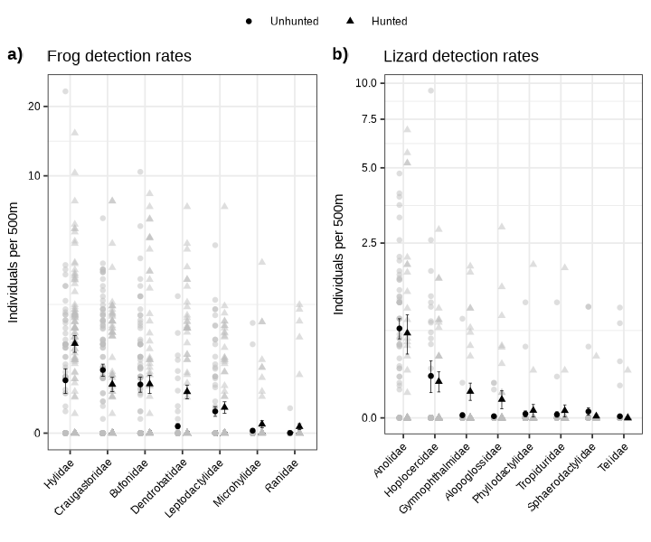
Figure 2. Points show mean number of individuals detected per 500 m during standardized surveys belonging to (a) the most commonly detected frog families and (b) all lizard families. Bars show standard errors. Detection rates per segment during the study are shown in the background in light gray. Note the frog families presented here were limited to instances where more than 10 individuals were detected in a family during the study to avoid overcrowding the plot. See supplementary figure xx and table xx for full details on families and species detected during surveys.

Table 2. Dietary guild, family, species, common name, and detection method (S = survey, O = opportunistic, or TP = third party) are given for each individual recorded in the hunted and unhunted forest.

 |  |  |  | Unhunted |  |  |  |  |  |  | Hunted
Guild | Family | Species | Common name | S | O | TP | Total | S |  | O | TP | Total
Non-mammal eaters | Colubridae | Atractus elaps | Coral Ground Snake | 0 | 0 | 0 | 0 | 0 |  | 0 | 1 | 1
Non-mammal eaters | Colubridae | Atractus major | Greater Ground Snake | 0 | 0 | 0 | 0 | 0 |  | 0 | 1 | 1
Non-mammal eaters | Colubridae | Atractus | Unidentified | 0 | 0 | 0 | 0 | 0 |  | 0 | 1 | 1
Non-mammal eaters | Colubridae | Chironius multiventris | South American Sipo | 4 | 1 | 1 | 6 | 0 |  | 7 | 0 | 7
Non-mammal eaters | Colubridae | Chironius scurrula | Wagler's Sipo | 0 | 0 | 1 | 1 | 3 |  | 2 | 0 | 5
Non-mammal eaters | Colubridae | Dendrophidion dendrophis | Olive Forest Racer | 0 | 2 | 0 | 2 | 0 |  | 0 | 0 | 0
Non-mammal eaters | Colubridae | Dipsas catesbyi | Catesby's Snail Eater | 3 | 1 | 0 | 4 | 1 |  | 1 | 0 | 2
Non-mammal eaters | Colubridae | Dipsas pavonina | Northern Snail Eater | 2 | 1 | 0 | 3 | 0 |  | 0 | 0 | 0
Non-mammal eaters | Colubridae | Drepanoides anomalus | Black-collared Snake | 3 | 2 | 0 | 5 | 0 |  | 0 | 1 | 1
Non-mammal eaters | Colubridae | Drymobius rhombifer | Diamond Racer | 0 | 1 | 0 | 1 | 0 |  | 0 | 0 | 0
Non-mammal eaters | Colubridae | Erythrolamprus aesculapii | Aesculapian False Coralsnake | 0 | 0 | 1 | 1 | 0 |  | 0 | 0 | 0
Non-mammal eaters | Colubridae | Erythrolamprus reginae | Royal Ground Snake | 0 | 0 | 0 | 0 | 0 |  | 1 | 0 | 1
Non-mammal eaters | Colubridae | Helicops angulatus | Brown-banded Watersnake | 1 | 0 | 7 | 8 | 7 |  | 0 | 2 | 9
Non-mammal eaters | Colubridae | Helicops pastazae | Shreve's Keelback | 0 | 0 | 0 | 0 | 0 |  | 1 | 0 | 1
Non-mammal eaters | Colubridae | Hydrops triangularis | Triangle Watersnake | 0 | 1 | 0 | 1 | 1 |  | 0 | 0 | 1
Non-mammal eaters | Colubridae | Imantodes cenchoa | Common Blunt-headed Tree Snake | 22 | 18 | 5 | 45 | 3 |  | 1 | 2 | 6
Non-mammal eaters | Colubridae | Imantodes lentiferus | Amazon Blunt-headed Tree Snake | 1 | 0 | 0 | 1 | 0 |  | 0 | 0 | 0
Non-mammal eaters | Colubridae | Leptodeira approximans | Upper Amazon Cat-eyed Snake | 0 | 4 | 0 | 4 | 0 |  | 0 | 1 | 1
Non-mammal eaters | Colubridae | Leptophis cupreus | Copper Parrot Snake | 1 | 0 | 0 | 1 | 0 |  | 0 | 0 | 0
Non-mammal eaters | Colubridae | Oxybelis inkaterra | Inkaterra Vine Snake | 0 | 0 | 0 | 0 | 0 |  | 1 | 0 | 1
Non-mammal eaters | Colubridae | Siphlophis cervinus | Panama Spotted Nightsnake | 2 | 0 | 0 | 2 | 0 |  | 0 | 1 | 1
Non-mammal eaters | Colubridae | Taeniophallus brevirostris | Short-nosed Groundsnake | 0 | 0 | 0 | 0 | 0 |  | 1 | 0 | 1
Non-mammal eaters | Colubridae | Tantilla melanocephala | Black-headed Snake | 0 | 0 | 0 | 0 | 0 |  | 0 | 1 | 1
Non-mammal eaters | Colubridae | Xenoxybelis argenteus | Striped-Sharpnose Snake | 2 | 5 | 1 | 8 | 1 |  | 3 | 1 | 5
Non-mammal eaters | Elapidae | Micrurus surinamensis | Aquatic Coralsnake | 0 | 0 | 0 | 0 | 1 |  | 0 | 0 | 1
Non-mammal eaters | Elapidae | Micrurus helleri | Western Ribbon Coralsnake | 1 | 0 | 0 | 1 | 1 |  | 0 | 0 | 1
Mixed | Colubridae | Chironius fuscus | Brown Sipo | 2 | 2 | 0 | 4 | 2 |  | 0 | 1 | 3
Mixed | Colubridae | Drymarchon corais | Yellowtail Cribo | 0 | 0 | 0 | 0 | 1 |  | 1 | 2 | 4
Mixed | Colubridae | Oxyrhopus occipitalis | Yellow-headed Flame Snake | 1 | 1 | 1 | 3 | 0 |  | 1 | 1 | 2
Mixed | Colubridae | Oxyrhopus petolarius | Forest Flame Snake | 2 | 0 | 1 | 3 | 0 |  | 0 | 0 | 0
Mixed | Colubridae | Oxyrhopus vanidicus | Impostor Flame Snake | 0 | 1 | 2 | 3 | 0 |  | 1 | 0 | 1
Mixed | Colubridae | Pseudoboa coronata | Crowned False Boa | 0 | 0 | 1 | 1 | 0 |  | 0 | 0 | 0
Mixed | Viperidae | Bothrocophias hyoprora | Amazonian Toadhead | 0 | 0 | 1 | 1 | 0 |  | 0 | 0 | 0
Mixed | Viperidae | Bothrops atrox | Common Lancehead | 0 | 0 | 0 | 0 | 0 |  | 0 | 1 | 1
Mixed | Viperidae | Bothrops bilineatus | Two-lined Forest Pitviper | 1 | 1 | 1 | 3 | 0 |  | 0 | 0 | 0
Mostly Mammals | Colubridae | Spilotes pullatus | Tiger Ratsnake | 0 | 0 | 0 | 0 | 0 |  | 0 | 1 | 1
Mostly Mammals | Boidae | Corallus batesii | Bates' Emerald Tree Boa | 0 | 1 | 0 | 1 | 0 |  | 0 | 0 | 0
Mostly Mammals | Boidae | Corallus hortulanus | Amazon Tree Boa | 2 | 6 | 1 | 9 | 3 |  | 0 | 1 | 4
Mostly Mammals | Boidae | Epicrates cenchria | Western Rainbow Boa | 1 | 2 | 0 | 3 | 2 |  | 4 | 0 | 6
Mostly Mammals | Boidae | Eunectes murinus | Green Anaconda | 0 | 0 | 0 | 0 | 2 |  | 1 | 1 | 4
Colubridae |  | Unidentified |  | 0 | 0 | 0 | 0 | 0 |  | 4 | 2 | 6

Snake Density Estimates

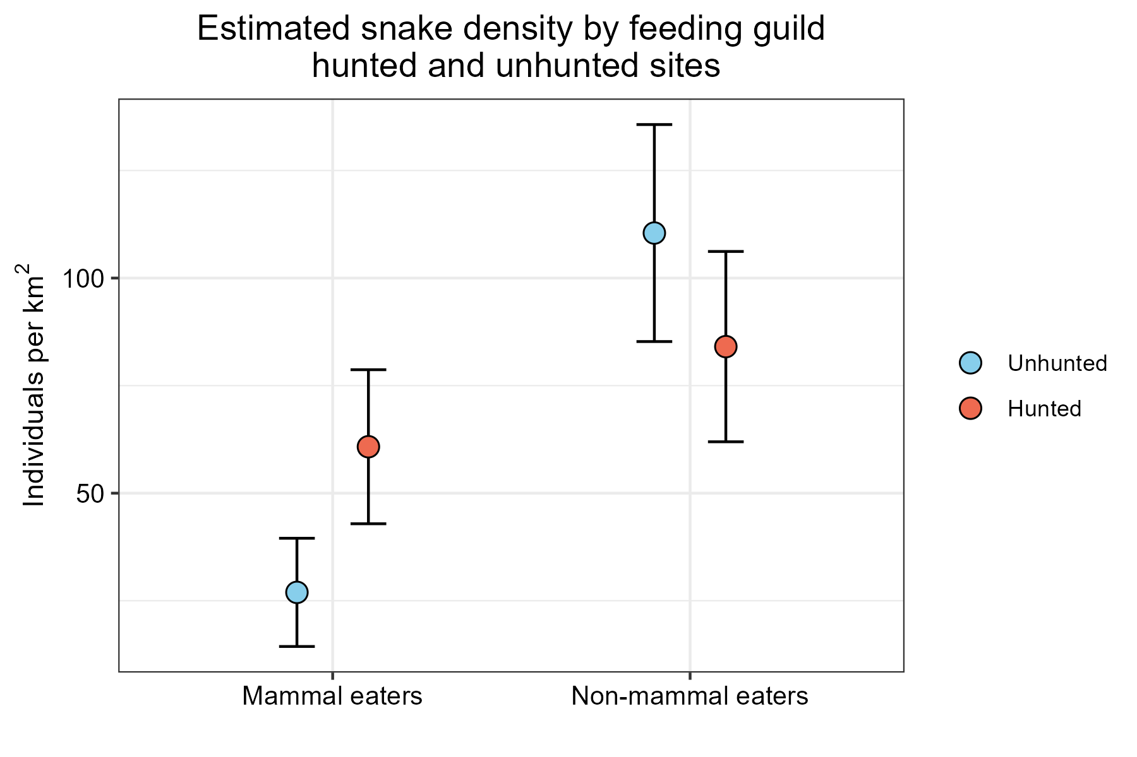
Figure 3. A crazy high density estimate for non-mammal eaters and a slightly more believable one for mammal eaters. Bars show 95% CI, I need to fix these models.

DISCUSSION

This study investigated whether defaunation driven by unsustainable hunting indirectly influences snake communities in the Ecuadorian Amazon by altering the availability of small mammal prey. We used standardized surveys as well as opportunistic and third-party observations in a hunted (defaunated) forest and a faunally-intact forest within Yasuní Biosphere Reserve to test the overarching hypothesis that mammal-eating snakes benefit from the increased small mammal abundances associated with defaunation. As expected, small mammal detections were significantly higher in the hunted forest, supporting the concept that losses of larger wildlife, specifically mammals, gives way for higher abundances of small mammals like rodents. We found some evidence supporting our expectation that this would translate into elevated densities of mammal-eating snakes, although more robust sampling is required to understand the significance of this potential effect of defaunation in snake communities. In general, most of the families of frogs and lizards we that we documented either increased in the hunted forest or showed no change; however, frogs in Craugastoridae were less abundant in the hunted forest. This aligns with previous work indicating this family is negatively impacted by the loss of litter turnover when peccaries and other large terrestrial animals are locally extirpated. Altogether, our results suggest that defaunation may alter the community composition of snake communities by affecting the mammalian prey base. However, these impacts on snake community structure are subtle, highlighting the need for further research to better understand this largely unrecognized consequence of defaunation.

Small mammal detection rates differed substantially between sites, reflecting the impacts of defaunation on the prey base for mammal-eating snakes in this system. The hunted site exhibited over three times as many small mammals detected per hour, supporting the hypothesis that reductions in larger-bodied mammals associated with defaunation release small mammals from predation and competition, ultimately benefitting their numbers. This pattern is consistent with many other studies throughout the tropics that document increased small mammal and rodent abundances in response to defaunation (Kurten 2013; Galetti et al. 2015b; Young et al. 2016). As larger mammals are removed from the system via hunting, this could give way for niches to be filled by small mammals, potentially increasing their access to resources. These findings reinforce the theory of defaunation potentially restructuring the prey base for snakes as well as other small-mammal-consuming taxa in tropical forest regions. Given the pronounced increase in rodents and other small mammals documented here and in related studies, the potential for this scenario to drive trophic cascades that change populations of species that consume small mammals (such as some snakes) warrants further research efforts. Increased densities of small mammals may serve as a useful indicator of how tropical systems are affected by defaunation, highlighting how increases in these species could signal broader overall trophic imbalance. Snakes in Yasuní Biosphere Reserve consume a wide variety of prey types (Arteaga et al. 2024), and defaunation may therefore have indirect effects on snake communities through multiple components of the prey base, including amphibians and reptiles, not just small mammals. One study done in the neotropics demonstrates that large-scale declines in amphibians can lead to cascading, bottom-up reductions in snake diversity (Zipkin et al. 2020), highlighting the importance of considering multiple prey pathways in future research regarding the ecological consequences of defaunation.

From a conservation perspective, these results reinforce the idea that ecological consequences of hunting can extend well beyond the species being directly removed from the system. Consistently higher detections of small mammals at the hunted site suggest that the effects of hunting not only cause declines in large-bodied game species, but also may include changes in less conspicuous components of the mammalian community. Monitoring changes in small mammal densities could provide a helpful way to detect broader potential ecological changes, and could be an indicator of a forest impacted by defaunation. Additionally, when coupled with evidence of higher densities of small mammal-consuming snakes in the hunted forest, these results suggest that hunting-driven changes in prey communities may extend to higher trophic levels and alter predator-prey interactions. These patterns highlight the importance of considering changes across multiple trophic levels when assessing the broader ecological results of hunting. Conservation strategies that monitor not only the recovery of hunted species, but also responses throughout the broader forest network, may be better suited to determine what the less visible consequences of defaunation are and how to address them.

The patterns observed with the frog and lizard prey base indicate that evidence of defaunation in these groups is slightly less obvious than that associated with small mammals. In some cases, frog detections differed significantly among families, with differences between forests particularly evident among families whose larvae undergo substantial terrestrial development. In forests with more intact mammalian faunal communities, peccaries and other ground-foraging mammals may alter the physical structure of the terrestrial environment through rooting and disturbance of leaf litter, potentially creating conditions that increase juvenile frog recruitment. This mechanism may be especially important for Amazonian frogs whose young go through substantial terrestrial development, as these species may be much more influenced by changes in leaf-litter structure than species with predominantly aquatic larval stages.

while lizards exhibited marginally higher detections at the unhunted site. Lizards exhibited marginally higher detections at the unhunted site. However, this can likely be attributed to differences in temperature between sites rather than indirect effects of defaunation. Although frogs and lizards make up an enormous portion of many Amazonian snakes’ diets, their populations do not appear to be strongly influenced by hunting pressure. These results suggest that the ecological pathways linking defaunation to snake communities may not be very strong, and also may be driven primarily by changes in small mammal prey availability rather than broader shifts across all major prey groups.

The patterns we saw with snake densities offers support for the idea that increased prey availability may influence predator populations and communities in defaunated forests. While most aspects of the snake community were broadly similar between sites, snakes that primarily consume mammals slightly showed marginally higher densities in the hunted forest relative to the unhunted forest, with Boidae exhibiting significantly higher densities. This aligns with our expectation that populations of snakes that consume high portions of small mammals, such as species from the family Boidae, may increase in density as a result of increased abundances of small mammals. We did not observe significant differences across other dietary guilds, suggesting that other ecological conditions between sites were largely similar and comparable, and that the observed pattern may be linked to changes in prey availability rather than broader habitat differences. Although our small sample size limits the strength of our inference, the trend is consistent with the hypothesis that defaunation can indirectly influence higher trophic levels (eg., snakes) by altering resource availability and restructuring prey communities. In systems where large mammals are reduced, shifts in prey availability, such as changes in abundance of small mammals, may create conditions that favor certain snake species (McCauley et al. 2006a), particularly groups that rely heavily on mammalian prey. If this pattern continues with future increased sampling effort, it could indicate a shift toward greater dominance of mammal-consuming snakes in defaunated tropical forest systems. These changes would have the potential to extend through the food web, influencing predator-prey dynamics across trophic levels. More broadly, these results highlight how defaunation may generate cascading ecological effects that extend beyond directly impacted taxa, reinforcing its issue as a key driver of community restructuring in tropical ecosystems.

Several limitations of this study should be considered when interpreting these results. To start, we treated existing trail systems as transects, which would impact some of the assumptions of typical distance sampling methods. Due to concerns about walking off trails through heavy vegetative cover and less navigable terrain, we used pre-cut trails for our surveys. To maintain the rigor of our survey protocols, we ensured accurate distance measurements of each segment via measuring segments separately from the surveys themselves to minimize additional meters added on by satellite error. Due to the overall low sample sizes of the snakes, especially from the ‘mixed’ and ‘mostly-mammal’ guilds, large alterations in the significance levels are attributed to differences in just a few observations. Snakes are very cryptic and difficult to detect by nature, so we cannot interpret with 100% confidence the results from our density estimates. Therefore, the density estimates presented here should be interpreted primarily as measures of relative differences, rather than as accurate estimates of true population densities in Yasuní Biosphere Reserve.

Our results provide some early potential evidence that defaunation driven by unsustainable hunting could be linked to changes in snake assemblages. Because snakes play an important role in tropical forest ecosystems, particularly as predators of a wide variety of taxa, yet are often underappreciated as ecological actors (Miranda & P 2017b), our study provides valuable insight into a relatively understudied aspect of defaunation. The trophic shifts suggested by our results indicate that changes in mammal communities may extend beyond directly impacted fauna and may influence other (eg. predator) trophic levels through altered prey availability. Increases in small mammal populations in defaunated systems may therefore support higher densities of mammal-eating snake species, potentially reshaping predator-prey dynamics and affecting additional components of the food web. Although these patterns were subtle and not always statistically strong, they suggest that defaunation influences community structure. Understanding these indirect effects is critical for developing a more complete picture of how defaunation alters tropical ecosystems. Further research incorporating larger sampling effort and longer-term studies will be important for clarifying these relationships and their broader conservation implications.

REFERENCES

Arteaga A, Bustamante L, Vieira J. 2024. Reptiles of Ecuador: Life in the Middle of the World. Khamai Foundation & Tropical Herping, Quito.
Bass MS et al. 2010. Global Conservation Significance of Ecuador’s Yasuní National Park. PLOS ONE 5:e8767. Public Library of Science.
Benítez-López A, Santini L, Schipper AM, Busana M, Huijbregts MAJ. 2019. Intact but empty forests? Patterns of hunting-induced mammal defaunation in the tropics. PLOS Biology 17:e3000247. Public Library of Science.
Blake JG, Mosquera D, Salvador J. 2013. Use of mineral licks by mammals and birds in hunted and non-hunted areas of Yasuní National Park, Ecuador. Animal Conservation 16:430–437.
Bogoni JA, Peres CA, Ferraz KMPMB. 2020. Extent, intensity and drivers of mammal defaunation: a continental-scale analysis across the Neotropics. Scientific Reports 10:14750. Nature Publishing Group.
Brooks M et al. 2022, July 12. glmmTMB: Generalized Linear Mixed Models using Template Model Builder. Available from https://CRAN.R-project.org/package=glmmTMB (accessed July 23, 2022).
Chua MAH, Thomas N, Teo RCH, Lim HC. 2026. Rapid population growth of greater mouse-deer after active forest restoration and African Swine Fever outbreak. Biological Conservation 313:111564.
Dirzo R, Young HS, Galetti M, Ceballos G, Isaac NJB, Collen B. 2014. Defaunation in the Anthropocene. Science 345:401–406. American Association for the Advancement of Science.
Espinosa S, Branch LC, Cueva R. 2014. Road Development and the Geography of Hunting by an Amazonian Indigenous Group: Consequences for Wildlife Conservation. PLOS ONE 9:e114916. Public Library of Science.
Garwood NC, Metz MR, Queenborough SA, Persson V, Wright SJ, Burslem DFRP, Zambrano M, Valencia R. 2023. Seasonality of reproduction in an ever-wet lowland tropical forest in Amazonian Ecuador. Ecology 104:e4133.
Ghanem SJ, Voigt CC. 2014. Defaunation of tropical forests reduces habitat quality for seed-dispersing bats in Western Amazonia: an unexpected connection via mineral licks. Animal Conservation 17:44–51.
Hartig F, Lohse L. 2022. “DHARMa”: Residual Diagnostics for Hierarchical (Multi-Level/Mixed) Regression Models. Available from https://cran.r-project.org/web/packages/DHARMa/DHARMa.pdf.
Holbrook KM, Loiselle BA. 2009. Dispersal in a Neotropical tree, Virola flexuosa (Myristicaceae): Does hunting of large vertebrates limit seed removal? Ecology 90:1449–1455.
Lamperty T, Zhu K, Poulsen JR, Dunham AE. 2020. Defaunation of large mammals alters understory vegetation and functional importance of invertebrates in an Afrotropical forest. Biological Conservation 241:108329.
Maynard RJ, Aall NC, Saenz D, Hamilton PS, Kwiatkowski MA. 2016. Road-Edge Effects on Herpetofauna in a Lowland Amazonian Rainforest. Tropical Conservation Science 9:264–290. SAGE Publications Inc.
Osuri AM, Mendiratta U, Naniwadekar R, Varma V, Naeem S. 2020. Hunting and Forest Modification Have Distinct Defaunation Impacts on Tropical Mammals and Birds. Frontiers in Forests and Global Change 2. Frontiers. Available from https://www.frontiersin.org/journals/forests-and-global-change/articles/10.3389/ffgc.2019.00087/full (accessed February 17, 2026).

SUPPLEMENTARY MATERIALS
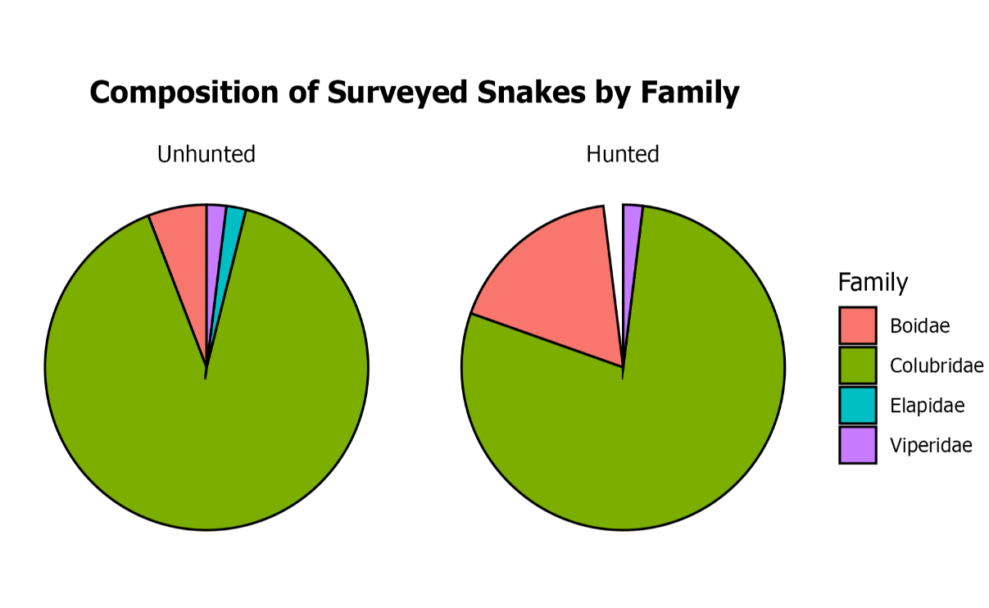
Figure S1. Composition of snake communities at the family level. Only individuals detected by survey were included.

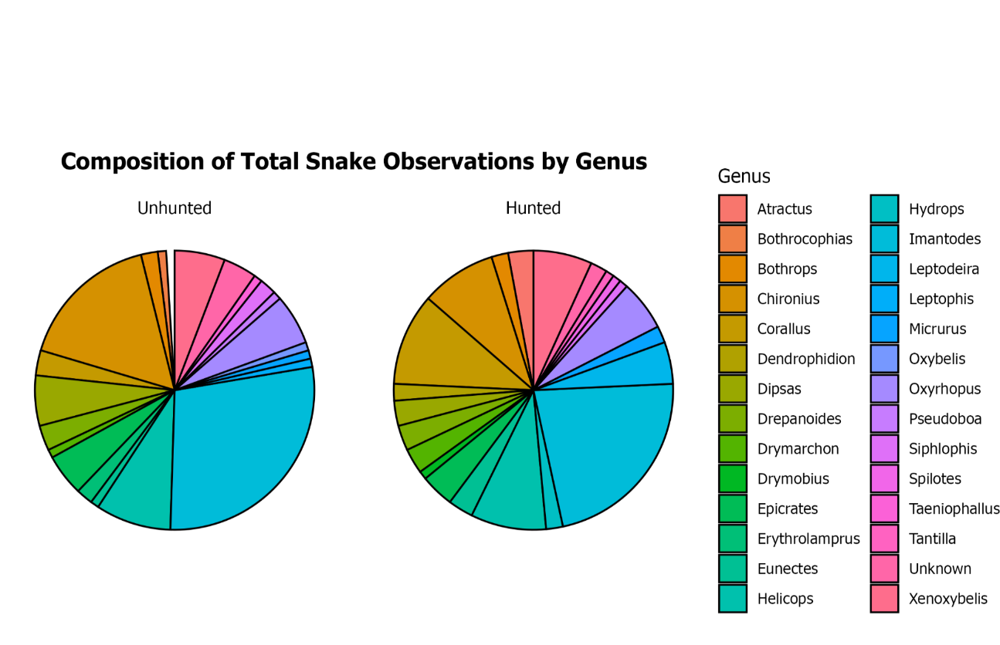
Figure S2. Snake genera encountered on survey, opportunistically, and by third parties.

